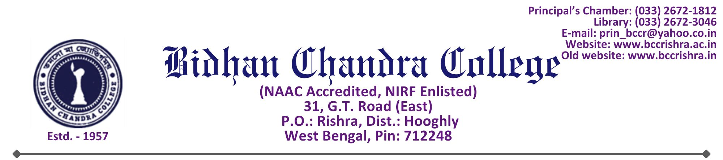

THE DETAILS OF ALL SUSPENDED OFFICIALS AND STAFF TABULATED AS PER FORMAT GIVEN BELOW:

Name of the suspended Employee | Name of the office/institution with address | Suspended from | Reason for suspension | Any other details
NA | BIDHAN CHANDRA COLLEGE  31, G.T. ROAD (EAST), RISHRA, HOOGHLY (W.B.) | NA | NA | NA

Dr. Ramesh Kar
Principal
Bidhan Chandra College,
Rishra, Hooghly

